Q25 Write a program to implement a basic calculator using switch-case for +, -, *, /, %.

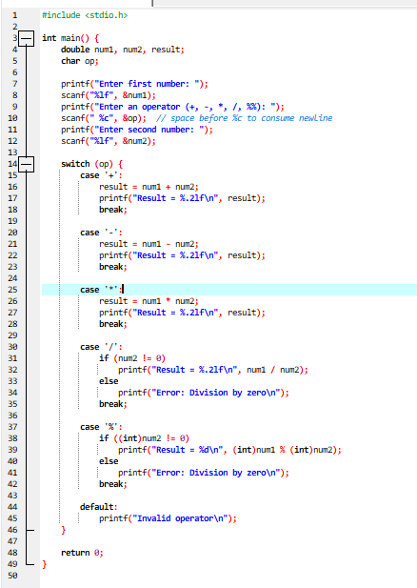

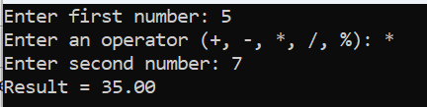
Q26 Write a program to print numbers from 1 to n.

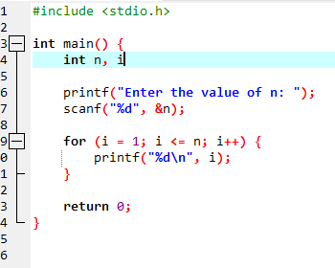
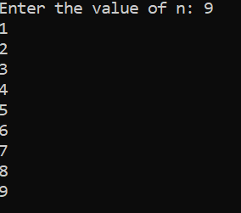
Q27 Write a program to print the sum of the first n odd numbers.

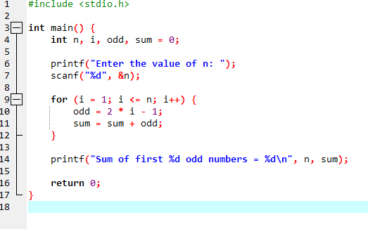

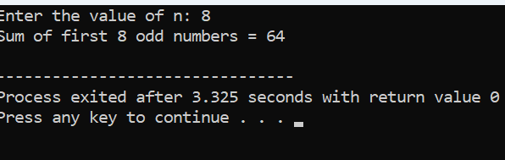

Q28 Write a program to print the product of even numbers from 1 to n.
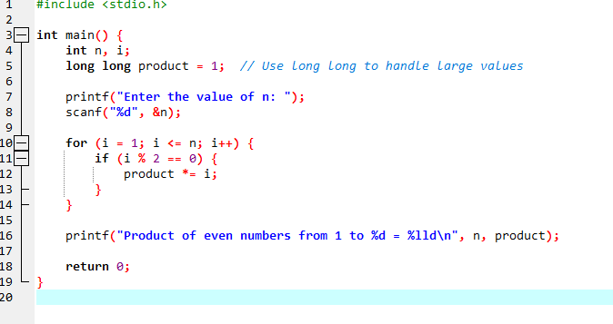
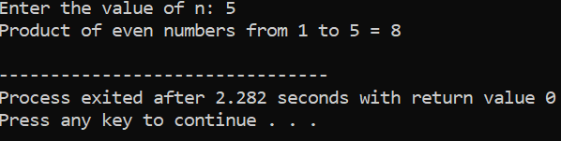
Q29 Write a program to calculate the factorial of a number.

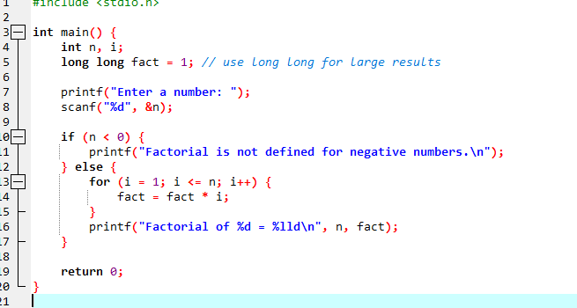
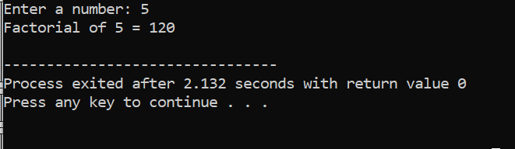
Q30
Write a program to reverse a given number.

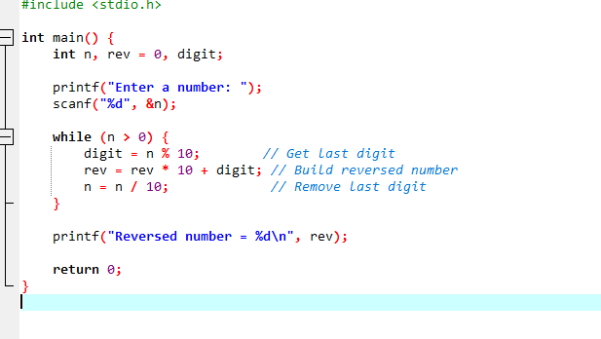
Result
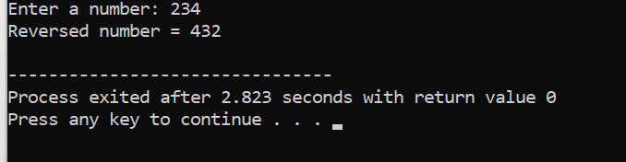
Q31 Write a program to take a number as input and print its equivalent binary representation.

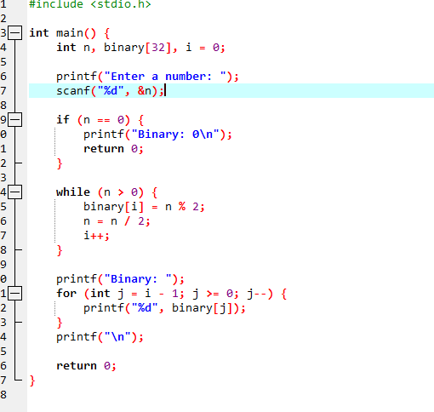
Result
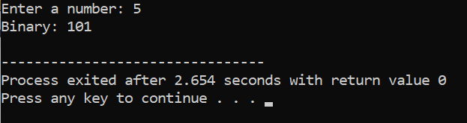
Q32. Write a program to check if a number is a palindrome.

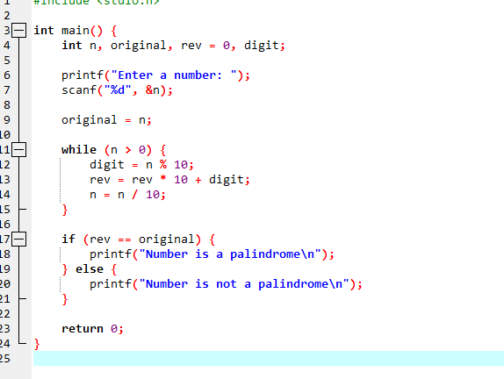
Result

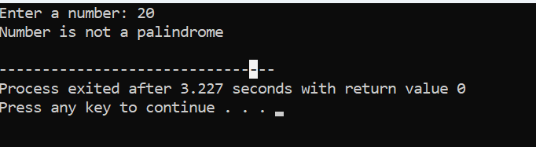

Q33 Write a program to check if a number is an Armstrong number.
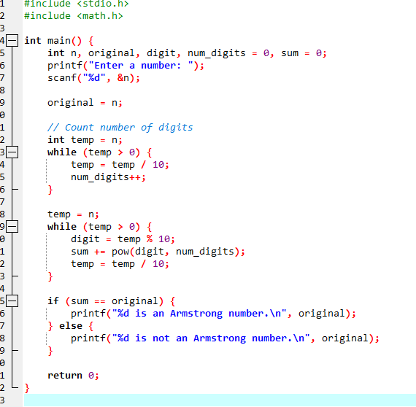

Result
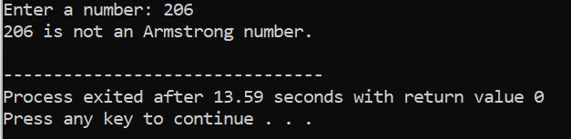

Q34 Write a program to check if a number is prime.

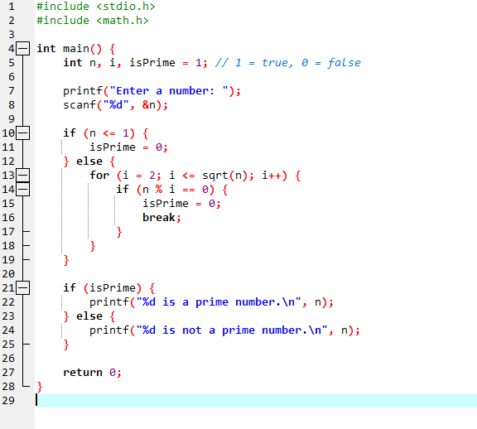
Result
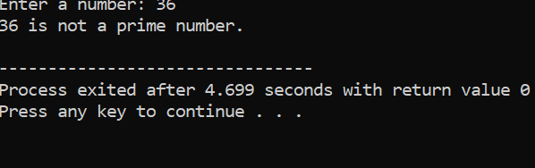
Q35 Write a program to print all factors of a given number.

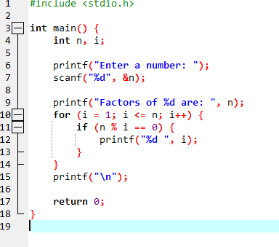

Result
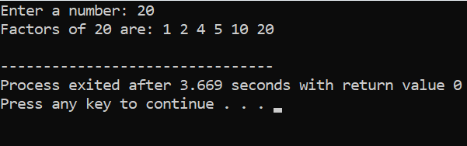
Q36 Write a program to find the HCF (GCD) of two numbers.

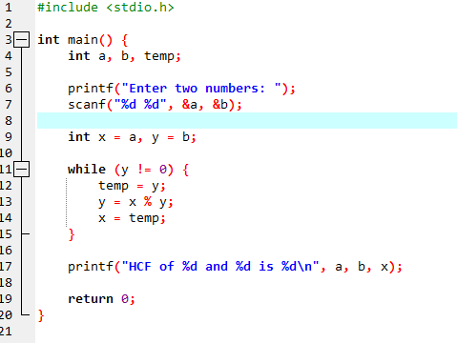
Result
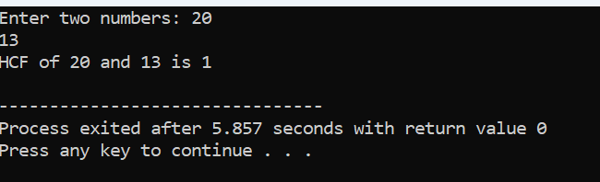
Q37 Write a program to find the LCM of two numbers.

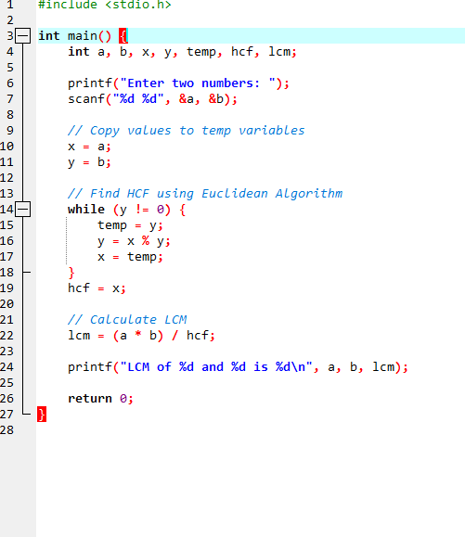
Result

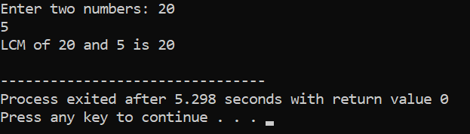

Q38 Write a program to find the sum of digits of a number.

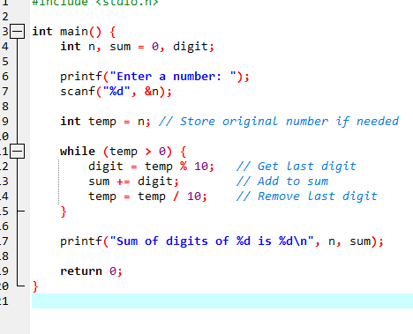
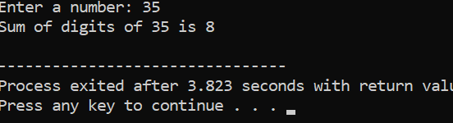
Q39 Write a program to find the product of odd digits of a number.
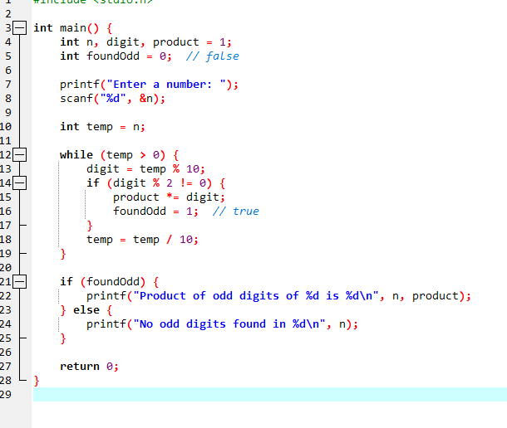

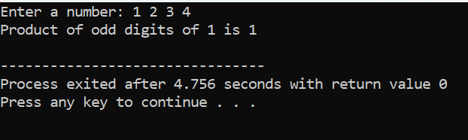
Q40 Write a program to find the 1’s complement of a binary number and print it.

